UBC BIOLOGY 121- not for resale

**READINGPEDIGREES**

The following pedigrees show the inheritance of a trait known as ACHOO syndrome (or photic sneeze reflex), a condition whereby people break into a sneezing fit upon sudden exposure to bright light.

What are the possible modes of inheritance of photic sneeze reflex?

For the left pedigree assign genotypes (using A and a) assuming the trait is autosomal dominant. For the right pedigree assign genotypes assuming the trait is autosomal recessive.

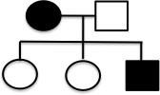

Now try to assign alleles assuming the trait is sex-linked (on the X chromosome) for both dominant (left) and recessive (right) inheritance.



Determine the possible modes of inheritance of the “affected” phenotypes shown in the following pedigrees (see next page), and the genotypes of as many individuals as possible. (These pedigrees are from Griffiths et al., Introduction to genetic analysis).

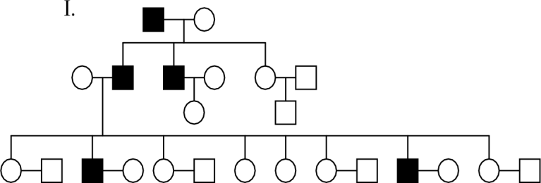

# II.

III.

